Granite Steps for Quality (GSQ)
As of May 23, 2022
Frequently Asked Questions (FAQ) *
*FAQs are subject to change. In addition, corrections will be made for errors, omissions and changes as needed.
All NEW FAQs are highlighted in YELLOW
General Knowledge
- What is “Granite Steps for Quality” (GSQ)?
a. Granite Steps for Quality (GSQ): NH's Quality Recognition and Improvement System (QRIS) is a system that recognizes program quality. GSQ is designed to assess, improve, and communicate the level of quality in a program.

- What are the benefits of GSQ?
a. NH’s QRIS: Granite Steps for Quality benefits families and children, programs and individuals, as well as the NH Community. Families and Communities deserve high quality care and education.
b. Programs can receive incentives through New Hampshire Child Care Scholarship Program participation, quarterly and annual quality bonuses, and program support through participation in NH’s QRIS: Granite Steps for Quality.

- How do I apply for NH’s QRIS: Granite Steps for Quality?
a. You can apply for NH’s QRIS: Granite Steps for Quality here: https://nhpublichealth.force.com/nhccis/s/login/?ec=302&startURL=%2Fnhccis%2Fs%2F

- If you need log in assistance to access NHCIS, please use the SUPPORT button on the log in page.

- What are blockers that may cause a delay in my GSQ Application review/ award?
  - Some items that may cause a delay in a GSQ Application review and award include: an expired BRC status, programs having outstanding Statement of Findings with CCLU, or any other CCLU issues that have not been resolved with a program/ providers at a program.
  - Please note that if any of these situations are occurring applicants can still apply for the GSQ system however the review team is not held to the 90 day commitment to review and award a Quality Step. Once BCDHSC hears from CCLU that the program is in compliance, the review team will begin the application review and award process as appropriate.
  - If any of these situations apply, please email NHGSQ@dhhs.nh.gov and we will work with CCLU to better assist the applicant.

- Who can I call for help with my NH’s QRIS: Granite Steps for Quality Application?
  - Child Care Aware of NH offers resources for early care and education programs 603-578-1386, ext. 2532 or via email at ccrrta@snhs.org
  - ACROSS NH offers resources for Out-of-School Time programs 603-206-6848 or via email at acrossnh@seresc.net
  - BCDHSC Credentialing Specialist, Annmarie Censullo 603-271-4684, Annmarie.S.Censullo@dhhs.nh.gov
  - BCDHSC Professional Development Specialist, Andrea Foster 603-271-9304, Andrea.J.Foster@dhhs.nh.gov

- What are the important dates related to GSQ that I need to know?
Date | What | Things to Know
December 31, 2021 | Previous deadline for expired LP programs | This date has been extended
May 31, 2022 | Approximate application deadline for program to be awarded by August, 2022* | *The approval process can take up to 90 days. This is just a suggested date to apply if a program wishes to be awarded by the August 30, 2022 deadline.
August 30, 2022 | Deadline to have applied and be awarded for all LP programs with expiration dates prior to August 30, 2022 | In order to not have a break in quality incentive funding providers must be in the new GSQ system by August 30, 2022.
August 30, 2022 | Deadline to have applied and be awarded for accredited programs who currently bill for child care scholarship. | In order to not have a break in quality incentive funding accredited providers who currently bill for c  hild care scholarship must be in the new GSQ system by August 30, 2022.
September 30, 2022 | Approximate application deadline for program to be awarded by December, 2022* | *The approval process can take up to 90 days. This is just a suggested date to apply if a program wishes to be awarded by the December 31, 2022 deadline.
December 31, 2022 | Deadline to apply and be awarded for all LP programs due for renewal between September 1, 2022 and December 31, 2022 | The approval process can take up to 90 days
December 31, 2022 | Deadline to apply for all LP programs due for renewal after December 31, 2022* | *Programs expiring after 2022, must only apply by the December 31, 2022 deadline. Please allow up to 90 days for the review/ approval process.

- If I have more than one site, do I have more than one GSQ application?
  - Yes, each site (by license number) must submit a GSQ application if the site wants to participate in the GSQ system. Steps will be awarded by license number.

- What do the renewal and continuous quality pieces look like? Will there be annual reporting between cycles?
  - No there are no reports due in between renewal periods. In The GSQ application, the attestation contains a commitment to continue staff credential requirements for current award level.

- How will the renewal process go?
  - On the NHCIS, GSQ Dashboard, providers will be notified when GSQ expiration date is approaching. 6 months prior to the renewal date, applicants will be able to submit their application on NHCIS.
  - BCDHSC staff will reach out to provider with any questions or missing information.

- Once I am award a Step in GSQ, how soon can I apply for a different Step?
  - At this time, once awarded a Step in GSQ, a program must remain at that Step for a minimum of one year.

- How is information shared about Granite Steps for Quality programs with families?
  - Families receive information about Granite Steps for Quality through the referral process by Child Care Aware of NH. Eventually this quality designation will be on Program Profiles in New Hampshire Connections Information System (NHCIS). Families seeking referrals through Child Care Search will be able to view your quality status online.

- How long is my GSQ level status valid?
  - Programs should work to maintain their achieved Step throughout the three year period, however, at time of renewal providers will need to submit proof of requirements.

- What is the difference between an Assessor and a Coach? When/Where are they used? (See ERS/ Coaching section of FAQ)
  - Assessor: ERS Assessors will be assigned to a program applying for a Step 3 (if not Accredited or HS/EHS) or Step 4. The ERS Assessor will visit the program to assess required amount of classrooms. Coaching will be assigned based on scores (see Coach below).
  - Coach: Practice-Based Coaches will work with programs using two week cycles over the course of 6 months. If a program’s Assessor score (Step 3) is lower than an average of a 3.5 with no classroom scoring lower than a 2.5 on activities and interaction, then a coach will be assigned to the program. If a program’s Assessor score (Step 4) is lower than an average of a 4.5 with no classroom scoring lower than a 3.5, then a coach will be assigned to the program.
  - Assessors and Coaches will be assigned to programs by BCDHSC staff.

- What are the approved Business Practices Trainings to meet the prerequisites?
  - Please note, administrators are only required to complete two courses from the following four trainings:
    - Taking Care of Business: An Administrator's Overview.
    - Leading with Heart: How to Build Effective Teams.
    - Successful Coaching and Mentoring for Employee Growth.
    - An Administrator's Overview of Assessment in Early Care and Education.
    - *Creating a Business Plan for Your Family Child Care Program
    - *Budgeting and Financial Planning for your Family Child Care Program

*These trainings are most applicable to Family Child Care Providers

- What if you don't have availability for the children who are inquiring with Child Care Scholarship?
  - Programs must be enrolled to receive children who are eligible for CCS and must accept them when enrollment space permits.

- If we offer both Out-Of-School Time and Early Childhood but are not sure if we want to identify both in the GSQ System what rubric would we use?
  - If you serve both Early Childhood and OST age children, please honor your program’s license and utilize the Center Based Programs Providing both Early Childhood and Out-of-School Time Services Rubric on p. 25 of the GSQ Publication.
  - If you feel that your license does not best represent the ages you currently serve, please contact CCLU regarding the appropriate license.
  - Note, the GSQ application built in NHCIS is connected to your license type in the system. (E.g., if a programs serves infants, toddlers, and school age children, the program will see a GSQ application covering all listed ages on the license).
  - If you have questions regarding your individual program structure please email NHGSQ@dhhs.nh.gov .

- If we are licensed 6 weeks-12years, and have a few kindergarteners do we still utilize the Center-Based Rubrics or would we need to use a different one?
  - In this case, a program would utilize the Rubric, “Center Based Programs Providing both Early Childhood and Out-of-School Time Services” in p.22-26 of the GSQ Publication .
GSQ Application on New Hampshire Connections Information System (NHCIS)
- What is a “Bridges ID” number on the GSQ Application on NHCIS?
  - This is the same as the Resource ID number. This number can range from 5-10 digits. If you do not know this number you can contact Marlene Burton at Marlene.M.Burton@dhhs.nh.gov for more information.
- My Resource ID number is only 5 digits but the application says it must be 6 digits. How do I complete this on the GSQ NHCIS Application?
  - Please put a “0 (zero)” in front of your Resource ID number if it is only 5 digits.

- Where do I upload documentation from watching required prerequisite, The Bedrock of the Granite State Video?
  - Directly in the GSQ application on NHCIS, there is a place for providers to upload documentation (a printable self-study) after viewing this video. The self-study is also available for providers in the application in blue text. See image below:
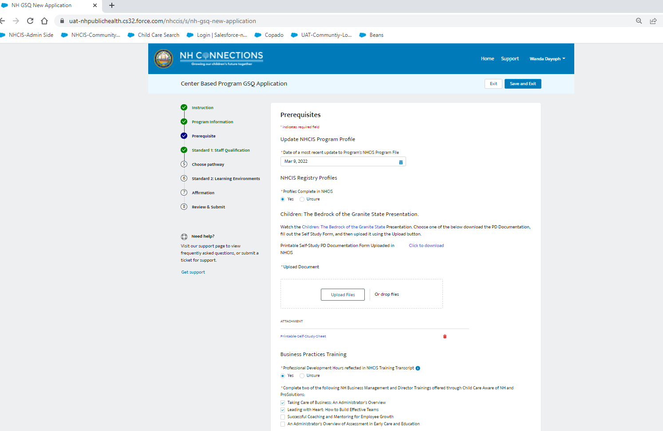

- I have paper documentation of proof of the required business practices, where do I upload these documents?
  - These documents can be uploaded directly to the provider’s Professional Registry in NHICS. See image below: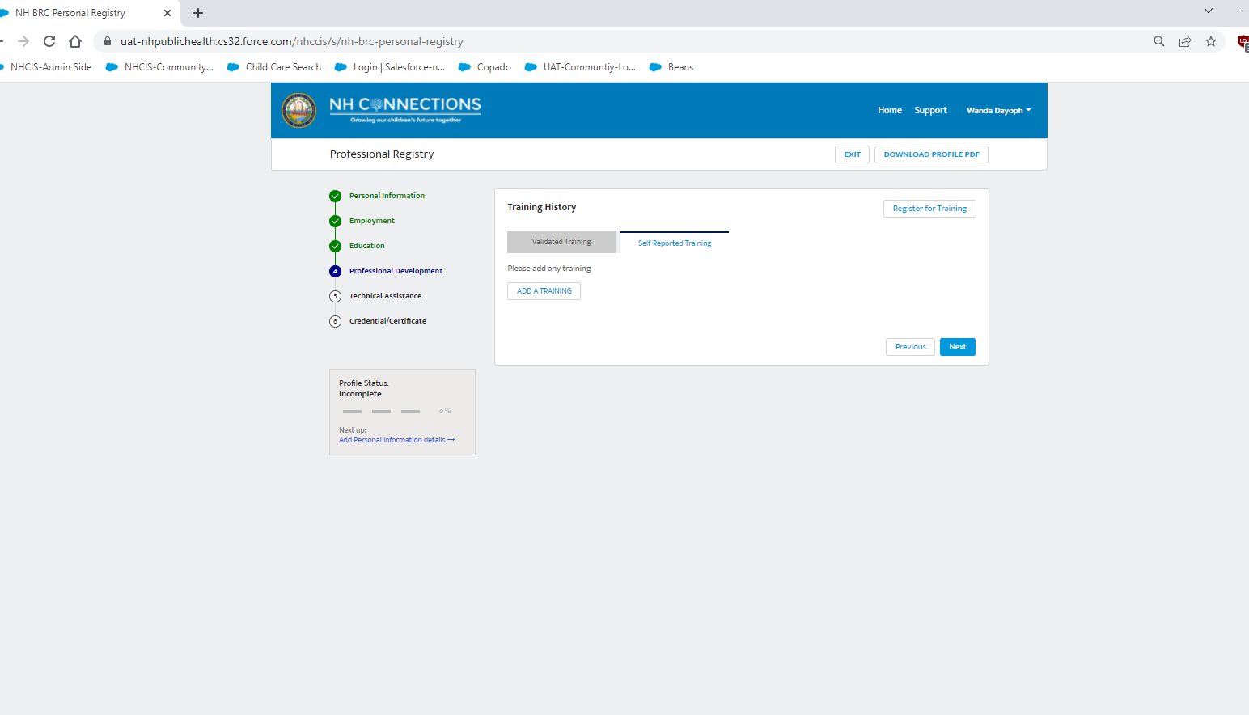
- As required in the GSQ application on NHCIS, I updated our program profile however, I cannot see the correct date that I last updated the profile on my end, why is this?
  - Applicants cannot see the date that they updated their profile last, however, administrators of the system (BCDHSC, CCLU, and CCAoNH staff) can see this information. Please note that if you updated your program profile, you completed this requirement of the GSQ Application and all you need to do is simply fill this date in on your GSQ Application.
  - If a GSQ reviewer has any questions regarding your application we will contact you via email.
Quality Incentives
- How much money will my program receive in quality incentive bonuses?
  - The amount of money awarded will vary on program type, Step awarded, and licensed capacity of the program. Please see the award amounts in the GSQ publication on p. 28-29.
- What is the timeline to be awarded a GQS Quality Step in order to receive GSQ quarterly incentives? ¹
# Quarterly Bonus Incentive | Date by which GSQ Quality Step Must be Awarded | Quarterly Bonus “End of Quarter” Date | Estimated Date by which Program may Expect to Receive Quarterly Bonus Payment²
1 | February 28 | March 31 | May 15
2 | May 31 | June 30 | July 15
3 | July 31 | September 30 | October 15
4 | November 30 | December 31 | January 15 of new year
¹“e. A program must be awarded their GSQ Quality Step at least 30 days before the end of the quarter in order to be eligible for that quarter’s GSQ Quality Bonus. Programs that progress to a higher GSQ Quality Step during the quarter, but at least 30 days before the end of the quarter, will receive the bonus associated with their new GSQ Quality Step” (p.28, Granite Steps for Quality Publication)
² This timeframe is an estimate. BCDHSC will submit the request for quarterly bonus payments to Finance within one week of the end of each quarter. Finance will process the payment requests and send to Accounts Payable to issue/mail a check to the program. It can take up to 25 days for programs to receive a check in the mail once submitted to fiscal.

- For quality incentive payments, will there be a required annual report?
  - Yes, similarly to those receiving quality incentive payments for programs currently accepting children receiving child care scholarship, there will be a reporting requirement included.

- How can I spend my Quality Incentive bonuses?
  - The Site Director is able to allocate funds as they see fit, providing that the money is spent on Quality Improvements. Things that would fall under the Quality Improvement umbrella include but are not limited to: materials for children, materials for staff, classroom furniture, playground equipment, building and grounds improvements, family events, staff bonuses, etc. Programs will be asked to report annually on how they allocated their Quality Funds.
Standard 1, Staff Qualifications Questions

- Who can I contact for help with my Credential Application?
  - Credentialing/Staff Qualifications: BCDHSC Credentialing Specialist, Annmarie Censullo 603-271-4684, Annmarie.S.Censullo@dhhs.nh.gov.
- Who can I contact for Technical Assistance?
- Early Childhood Program: Child Care Aware of NH at 1-855-393-1731 or 603-578-1386, ext. 2526 or ext. 2532 or e-mail at ccrrta@snhs.org.

- Out-of-School Time Programs: ACROSS NH at 1-603-206-6848 or e-mail at acrossnh@seresc.net.

- Who is considered a Program Administrator?
  - A Director (or Provider of a Family Child Care) or Assistant Director of the program applying.

- What constitutes as "eligible" staff?
  - Eligible staff for early childhood programs are lead teachers and associate teachers as defined by CCLU requirements. The staff member should be both qualified for, and acting as a lead or associate teacher.
  - For Out-of-School Time programs, eligible staff are group leaders, site directors and site coordinators, as defined by CCLU requirements. The staff member should be both qualified and serving as a group leader, site director, or site coordinator.
  - Credentials must not be expiring within 90 days of GSQ application date (remember, the GSQ application review and approval process can take up to 90 days). Our credentialing specialist will reach out to providers to request a credential renewal if a GSQ application is received with current credentials expiring with-in 90 days of GSQ application date.

- What if 30% of eligible staff is 2.4 do I round up or down?
  - If half of your eligible staff is a decimal number, please round up. So in the example listed, the number of eligible staff would be 3.

- If I share staff between my Early Childhood and Out-of-School program, how will that effect my percentages?
  - Providers must be credentialed the required amount stated on the rubrics for each Out of School Time and Early Childhood.

- If somebody is an associate teacher by CCLU standards but operates as an assistant does their associate status with licensing automatically make them eligible staff according to the rubrics?
  - For the purpose of GSQ, whichever credential the staff member holds will count towards the application.
- What happens with teachers that are considered Per Diem Teachers? They are Lead or Associate Teachers, but are not considered to be all-year staff, would they still be counted in my percentages? (IE: College Students, Summer Help, etc.)
  - If the staff are working at the time of GSQ application, yes, they count towards the percentage of eligible staff required for Standard 1, Staff Qualifications.

- Do my part-time staff count in the ratios for staff? If they are working 15-30 hours per week but are Lead/Associate Teachers in classrooms, would they still be considered in my staff percentages?
  - Yes, as long as they fall into the definition of “eligible staff” (see #5 in this section above).

Standard 2a, Learning Environments - Environment Rating Scales Questions

- Where can I learn more about ERS?
  - To find information about implementation ERS within your program you can visit the “Environment Rating Scales” page of NH Connections.
- How do I submit proof of my ERS Self-Assessment?
  - Providers can submit their ERS Self-Assessment documentation within their GSQ application on NHCIS. There is a specific section to upload this documentation. Please have this prepared when completing the application as it is required to move forward with the application.

- What are the approved ERS Trainings?
  - Any ERSI Training
  - Or for free, you can contact CCAoNH and/or ACROSS NH for their ERS training.
  - https://files.constantcontact.com/49b439d5301/995cb3fc-17bf-4bd8-b971-c83892a16563.pdf
  - Out-of-School Time: You can find training information for ERS Overview: SACERS training here: https://www.acrossnh.org/granite-steps-for-quality
  - Trainings must be current (within the last three years from application date) to be counted.

- How do we get assigned an ERS Assessor?
  - The Bureau of Child Development and Head Start Collaboration will assign the coach and/or assessor as applicable to programs applying for Steps 3 and 4.
Standard 2b, Learning Environments- Pyramid Model Questions

- Can Out-of-School Time providers follow the Pyramid Model Pathway?
  - There is no Pyramid Model Pathway for Out-of-School time programs. However, if your program serves both early childhood and Out-of-School Time, you can choose the Pyramid Model Pathway for your early childhood program and use choose the SACERS pathway for the Out-of-School Time program.

- How do we get assigned a Pyramid Model Coach?
  - The Bureau of Child Development and Head Start Collaboration will assign the coach and/or assessor as applicable.
  - If you are not currently participating in Pyramid Model but wish to go the Pyramid Model Pathway, please email us your program information at NHGSQ@dhhs.nh.gov so we can connect you with our partners for coaching.

- Where can I access the tools for the Pyramid Model?
  - The Program Coach assigned to your program will provide the Teaching Pyramid Observation Tool (TPOT) and/or the Teaching Pyramid Infant-Toddler Observation Scale (TPITOS). You can also learn more about the scales by reading the fact sheets found here: https://ptan.seresc.net/blog/teaching-pyramid-observation-tool-tpot/

- Do I need to take the entire "Pyramid Model Taking Care of yourself" module series (2 hours) Or the first module titled, "Taking Care of Yourself"?
  - Yes, the requirement from the rubric is speaking to completing the entire training module (2 hours).
- As a Family Care Provider caring for children birth to five, I have taken the Pyramid Model Framework Modules can I apply for that Learning Environment Standard?
  - At this time, the Pyramid Model Pathway is specific to Center Based Early Childhood Programs but stay tuned, we will be adding in this pathway for Family Child Care Providers in the near future.
- Where can I find current Professional Development Opportunities pertaining to Pyramid Model?
  - Professional Development opportunities will be listed in NHCIS and are often in the annual training offerings from Child Care Aware of NH and/or ACROSS NH. You can also locate Pyramid Model e-modules on ProSolutions.
- Where can I learn more about Social Emotional Development and Pyramid Model?
  - To find information about how to bring the Pyramid Model Framework to your program you can visit the “Social Emotional Development” page of NH Connections.

- How can I access the Benchmarks of Quality (BOQ)?
  - A Program Coach will work your Leadership Team to complete the Benchmarks of Quality (BoQ). You can find the document and other helpful tools on the National Center on Pyramid Model Innovations (NCPMI) here: https://challengingbehavior.cbcs.usf.edu/Implementation/data/index.html

- How can I request a TPOT or TPITOS Observation for my program?
  - If your program has applied for a Step 3 using the Pyramid Model Pathway, then a TPOT and/or TPITOS tool administrator matched to your program by the BCDHSC will assess the classrooms and report the scores.

- How can I apply for Practice-Based Coaching for my program?
  - Practice-Based Coaching is integrated into the GSQ for both Learning Environment pathways and will automatically occur at Steps 3 and 4. Coaching may be offered to programs engaging in this work at a Step 2 as well. Please reach out via email at NHGSQ@dhhs.nh.gov if your program is interested in coaching but is not ready for Steps 2-4 yet.

- How do I submit proof of my leadership team, mission and vision statements, completed Benchmarks of Quality (BoQ) and action plan based on the BoQ?
  - Your Program Coach will assist with reporting this work back to the BCDHSC.
  - If you are not currently participating in Pyramid Model but wish to go the Pyramid Model Pathway, please email us your program information at NHGSQ@dhhs.nh.gov so we can connect you with our partners for coaching.

- Do I need to do an overview of Pyramid Model before applying for Step 1 Pyramid Model Pathway?
  - If you have never been a Pyramid Model Implementation Site and have not completed the Progressive with CCAoNH, an Administrator and all Lead Teachers must complete the one hour training on ProSolutions: Building Positive Social Emotional Skills for All Children: Introducing the Pyramid Model Framework. Note: This is in addition to the required trainings listed in the GSQ Guide.
  - https://www.prosolutionstraining.com/store/product/?tProductVersion_id=2111

- Our program has been practicing Pyramid Model for a long time, and their pieces of training happened before ProSolutions. Do they need to present every certificate or can a director/coach make a master list?
  - Trainings must be from the last three years in order to be counted towards the GSQ application.

- If we’ve done TPOTs/TPITOS with iSocial already, will we have to do them again, or what documentation would be needed where these are confidential documents?
  - Observations must be current with GSQ application (within 30 days of application date). If an observation has already been done through iSocial within the last 30 days, the scores will still need to be uploaded in NHCIS.

GSQ Quality Steps 3 and 4
- I want to apply for a Step 3. How many classrooms will be observed for assessment and which ones?
- When an assessor comes to your program, half of your classrooms will be observed, covering the range of ages you serve. For example, if you have one infant, one toddler, one preschool, and one pre-k room, either the infant or toddler room will be observed and either the preschool or pre-k room will be observed. If you have one infant, one toddler, and six preschool rooms, the assessor will observe the infant and toddler spaces and two of the preschool rooms.
Accredited Programs
- My program’s NAEYC Accreditation is expired or was revoked. Can I be awarded a Step 3?
  - Programs must hold a current NAEYC Accreditation in order to apply and be awarded a Step 3. If your accreditation is not current, you may apply in the system by choosing one of the identified pathways and meeting the criteria for both standards in your chosen Step.

- What if my accreditation is expiring soon? What should I do?
  - If your program intends to renew before your expiration date: Continue with your renewal process. Apply for intended GSQ Step and keep The Bureau of Child Development and Head Start Collaboration informed of your pending accreditation visit. (This is a case by case basis, especially due to a Pandemic). If there is a delay in your scheduled visit, please notify The Bureau of Child Development of Head Start Collaboration and we will work with you to achieve the Step for which you currently qualify.
  - If your program does not intend to renew accreditation: Apply for the Step that best fits your program structure. Please see the rubrics in the GSQ publication p. 12-26.

- My program is provisionally accredited. Can I be awarded a Step 3?
  - NAEYC Accredited and Provisionally Accredited Programs can apply to be awarded a Step 3. Programs must keep the Bureau informed of their Accreditation status, including expiration dates, renewal intentions, assessor visitation windows, etc.

- What is considered approved documentation for NAEYC Learning Environment Standards (Step 3)
  - Acceptable documentation includes NAEYC Accreditation Decision Report, NAEYC Renewal Accreditation Report, or Accreditation Evaluation Summary.
  - For staff qualifications, a NAEYC certificate will suffice.

- If we are an Accredited Program and our license is from 6 weeks- 12 years (both Early Childhood and Out-Of-School Time) what rubric do we complete?
  - If you serve both Early Childhood and OST age children, please honor your program’s license and utilize the Center Based Programs Providing both Early Childhood and Out-of-School Time Services Rubric on p. 25 of the GSQ Publication.
  - Since you are an Accredited program, you will be crosswalked in at Step 3 simply by providing proof of prerequisites and required NAEYC documentation. This will meet the requirement for both ECE and OST at your center. However, if you are wishing to move to a Step 4, then you must meet the requirements on the rubric for age groups served.
  - If you have questions regarding your individual program structure please email NHGSQ@dhhs.nh.gov .

Head Start/ Early Head Start & Accredited Crosswalk Step 3 and 4
- If I am cross walking into GSQ as an accredited/ Head Start and/or Early Head Start program at Step 3 and want to move up to Step 4, can I do this immediately?
  - A program must be in the system at Step 3 for minimum of 1 year before moving to apply for Step 4.

- How would centers navigate having HS/EHS and child care classrooms in one building?
  - If you are primarily a center based non Head Start/ Early Head Start program, please use the Center Based Early Childhood Programs rubric on p. 18 of the GSQ Publication.
  - Programs licensed as a Head Start/ Early Head Start, can choose to be crosswalked at a Step 3 by providing the required documentation.

- If my license has a Head Start classroom under my license, does that mean that the entire center would have to be at Step 3?
  - The Head Start and Early Start Head programs would have to have their own license in order to apply at Step 3, otherwise the program would apply using the Center Based application.
Endorsements
- If I am going to pick “Track 1” or “Track 2”, where do I find the Bringing the Protective Factor Framework to Life in your Work training?
  - A free training can be found on NH Children’s Trust*
    - First please visit: https://www.nhchildrenstrust.org/strengthening-families-training
    - Next, click “learn more and register”
    - This will redirect you to The Children’s Trust Fund Alliance. Scroll down to the bottom of the screen and click on, “Visit ProSolutions Training”
    - You will now find 1 free certificate (this does not yield a certificate at the end of the training). You can pay and receive a certificate to upload on your registry OR you can complete a self-study form and submit this on your registry (Self Study form can be found here: https://www.nh-connections.org/providers/trainings-and-recorded-webinars/ ).

Out of School Time Programs
- If a program is applying for both an OST and Early Childhood GSQ Step, can the program submit the sections separately or do they need to come in as one application?
  - Programs applying for both OST and Early Childhood GSQ Steps should utilize the correct rubric, Center Based Programs Providing both Early Childhood and Out-of-School Time Services, and need to submit their entire application as a whole. If you have questions regarding your individual program structure please email NHGSQ@dhhs.nh.gov .
- Do both administrators need to complete an approved SACERS training (such as, Introduction and Overview to ERS Training: SACERS) to apply for an OST Step?
  - An administrator and 25% of eligible staff are required to complete an approved SACERS training. Please see the OST rubrics in the GSQ Publication.

- For Steps 1 & 2, the rubric reads, “Program submits SACERS self-assessments for all groups using the SACERS tool.”
  - Are programs submitting all 6 subscale assessments? (Space and Furnishings, Health and Safety, Activities, Interactions, Program Structure, Staff Development)
    - Yes, programs are required to submit all 6 subscale assessments.
  - Special Needs Supplementary Items are not included in GSQ, correct?
    - This is correct. This is not included in the reporting requirement of GSQ.

- For Steps 3 & 4, are assessors observing all 6 subscales?
  - Yes, an assessor will observe the program using all 6 subscales.

